**Human Resource Information System**

Use Case Diagram

Submitted to:

Prof. Roy Vincent Canseco

Faculty Member

Department of Computer Science

College of Engineering

University of the Philippines, Diliman

Submitted by:

Evangelista, Treacy

Villarin, Cyan

In partial fulfillment of Academic Requirements for the course

CS 198 Special Problems I

Of the 1st Semester, A.Y. 2017-2018

**Unique Reference:**

The documents are stored in https://github.com/cyanvillarin/HRIS

File name: “Human Resources Information System – Use Case Model.pdf”

File reference: https://github.com/cyanvillarin/HRIS/blob/master/02-Requirements-Engineering/Human%20Resource%20Information%20System%20-%20Use%20Case%20Diagram.docx

**Document Purpose:**

The purpose of this document is to establish the primary specifications of the functionalities of the system. This will describe the goals of the users and the interactions between the users and the system.

**Target Audience:**

This is intended for the Office of the Vice Chancellor for Administration (OVCA) staff members.

**Revision Control:**

|  |  |  |  |
| --- | --- | --- | --- |
| **Revision Date** | **Person Responsible** | **Version Number** | **Modification** |
| 8/13/17 | Evangelista, Treacy  Villarin, Cyan | 1.0 | Initial Document |

*System Name*: Human Resources Information System (HRIS)

*Description*: HIRS is a web-application especially built for the staff members of the OVCA. The system will become a platform for the admin and the employees. The admin will be able to administrate the info of the employees, and the employees will be able to see their info and status.

*Use-Case Diagram* is on the next page.

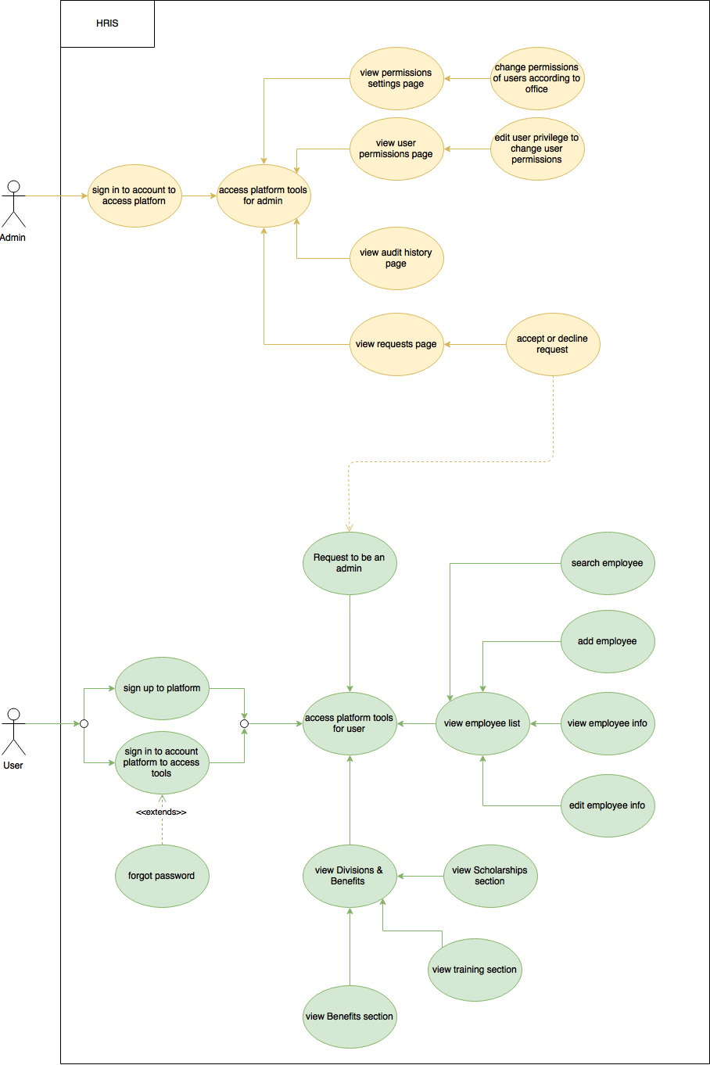List of Actors:

|  |  |
| --- | --- |
| **Actors** | **Description** |
| Admin | An admin is the one who is able to add users, change the details of a user, and approve a user to be an admin as well. |
| User | A user is the one who will be able to view the list of employees, the details of an employee, and view the employees group by divisions and sections. |

List of Use-cases:

|  |  |
| --- | --- |
| **Use-Case** | **Description** |
| Use-Case 1.0 Sign In |  |
| Use-Case 1.1 View Home Page |  |
| Use-Case 1.2 View User Permissions Page |  |
| Use-Case 1.3 View Audit History Page |  |
| Use-Case 1.4 View Permissions Settings Page |  |

|  |  |
| --- | --- |
| **Use-Case** | **Description** |
| Use-Case 2.0 Sign In |  |
| Use-Case 2.1 View Home Page |  |
| Use-Case 2.2 View Employees List |  |
| Use-Case 2.3 Click Divisions & Benefits Tab |  |
|  |  |